Wireframe: https://wireframe.cc/MFLxhU


Logo:

Color palette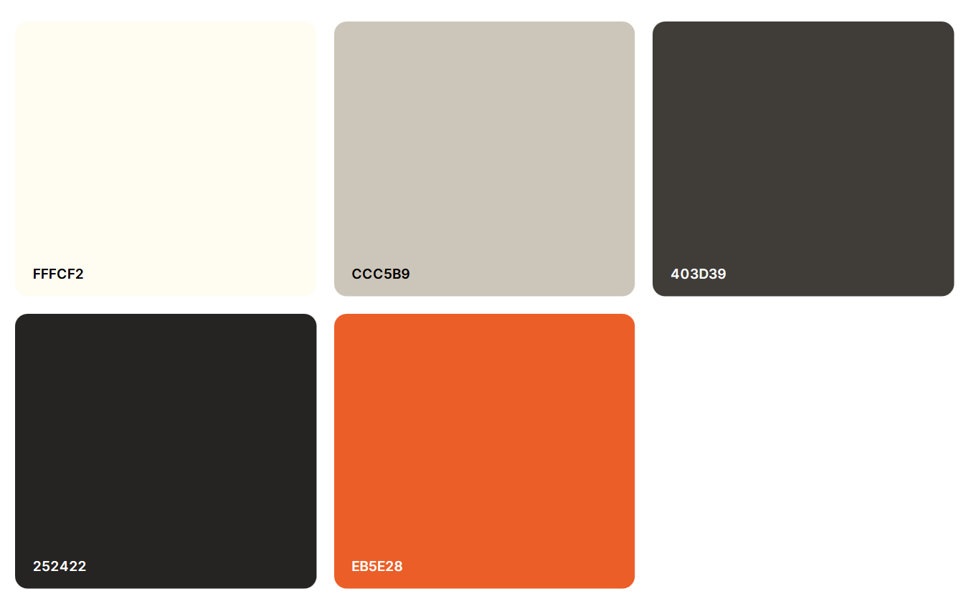
Accent Color 2
Accent Color 1
Color 2
Color 1
Background
(Alternative accent 2: #DA8700)
Header font: Modern Antiqua
Paragraph font: Playfair Display

(@import url('https://fonts.googleapis.com/css2?family=Modern+Antiqua&family=Playfair+Display:ital,wght@0,400..900;1,400..900&display=swap');)

Color source: coolors.co
Wireframe source: wireframe.cc
Fonts source: fonts.google.com
Logo design: Myself

